Project Report on
“Real-Time Tremor Compensation System for Precision Assistive Stylus Using Embedded Digital Filtering and PID Control”
Submitted in partial fulfilment of the requirement for completion of
PROJECT WORK 1 [23EC6PWPJ1]
Submitted by
Student Name | 1BM________
Student Name | 1BM________
Student Name | 1BM________
Student Name | 1BM________
Under the guidance of
Dr. Jisha P
<Designation>
BMS College of Engineering
Bengaluru
Academic Year
2025 – 2026
DEPARTMENT OF ELECTRONICS AND COMMUNICATION ENGINEERING
B.M.S. COLLEGE OF ENGINEERING
Bull Temple Road, Basavanagudi, Bengaluru-560019
Autonomous College, affiliated to Visvesvaraya Technological University, Belagavi

B.M.S. COLLEGE OF ENGINEERING
Autonomous college, affiliated to VTU
Bull Temple Road, Bengaluru – 560 019
DEPARTMENT OF ELECTRONICS AND COMMUNICATION ENGINEERING
CERTIFICATE
This is to certify that the Project Work 1 entitled “Real-Time Tremor Compensation System for Precision Assistive Stylus Using Embedded Digital Filtering and PID Control” is a bonafide work carried out by <Student Name> (1BM--------------), <Student Name> (1BM--------------), <Student Name> (1BM--------------) and <Student Name> (1BM--------------), submitted in partial fulfilment of the requirement for completion of PROJECT WORK 1 [23EC6PWPJ1] of Bachelor of Engineering in Electronics and Communication during the academic year 2025-26. The Project Work 1 report has been approved as it satisfies the academic requirements.
Guide  Dr. Jisha P  <Designation of guide>  Department of ECE  BMS College of Engineering | Head of Department  (Dr. K. P. Lakshmi)  Professor and Head  Department of ECE  BMS College of Engineering
(Dr. Bheemsha Arya)
Principal
BMS College of Engineering
External Viva
Name of the Examiners | Signature with Date
1.
2.

DECLARATION
We, <Student Name> (1BM----------), <Student Name> (1BM----------), <Student Name> (1BM----------), and <Student Name> (1BM----------), hereby declare that the Project Work 1 entitled “Real-Time Tremor Compensation System for Precision Assistive Stylus Using Embedded Digital Filtering and PID Control” is a bonafide work and has been carried out by us under the guidance of Dr. Jisha P, <Designation of the guide>, Department of Electronics and Communication Engineering, BMS College of Engineering, Bengaluru, submitted in partial fulfilment of the requirement for completion of PROJECT WORK 1 [23EC6PWPJ1] of Bachelor of Engineering in Electronics and Communication during the academic year 2025 – 26. The Project Work 1 report has been approved as it satisfies the academic requirements in Electronics and Communication Engineering, Visvesvaraya Technological University, Belagavi, during the academic year 2025 – 26.
We further declare that, to the best of our knowledge and belief, this Project Work 1 has not been submitted either in part or in full to any other university.
Place: Bengaluru | <Student Name: 1BM---------->
Date: | <Student Name: 1BM---------->
 | <Student Name: 1BM---------->
 | <Student Name: 1BM---------->

ACKNOWLEDGEMENTS
We take this opportunity to express our profound gratitude to the respected principal Dr. Bheemsha Arya, BMS College of Engineering, for providing a congenial environment to work in. Our sincere gratitude to Dr. K. P. Lakshmi, Head of the Department, Electronics and Communication Engineering, for encouraging and providing the opportunity to carry out Project Work 1 in the department.
We heartfully thank our guide Dr. Jisha P for the guidance and constant encouragement throughout the course of this Project Work 1, without which this project would not have been successful. The technical inputs offered during weekly reviews and the patience shown while clarifying our doubts have been invaluable in shaping this work.
A number of personalities, in their own capacities, have helped us in carrying out this Project Work 1. We would like to take this opportunity to thank Dr. Madhusudhan K N and Dr. Bhanu Prashant, who served as project reviewers, for their valuable comments and suggestions during the review sessions. We are also thankful to the lab in-charges and technical staff of the Department of ECE for facilitating access to components and equipment.
Last but not the least, we thank our friends and family for their encouragement and help in accomplishing the objective of Project Work 1.
1) Student’s Name : Student’s USN
2) Student’s Name : Student’s USN
3) Student’s Name : Student’s USN
4) Student’s Name : Student’s USN

ABSTRACT
Involuntary hand tremor in the frequency band of approximately 8–12 Hz interferes with fine motor tasks such as drawing, drafting and controlled writing. Although the amplitude of physiological tremor is small, its effect becomes noticeable on precision drawing surfaces, where smooth, continuous lines are required. Existing solutions either rely on heavy computational algorithms running on personal computers or on costly medical-grade hardware, and are therefore not suitable for low-cost, classroom-style assistive demonstrations.
This project develops a compact tremor compensation stylus that detects hand motion in real time and physically counteracts the unwanted oscillations before the stylus tip reaches the writing surface. An MPU6050 inertial measurement unit mounted on the stylus body captures three-axis acceleration and gyroscope data. An ESP32 microcontroller samples this data at 100 Hz, isolates the tilt angle of the stylus, and passes it through a first-order exponential low-pass filter that attenuates the tremor band while preserving voluntary motion. The error between the filtered orientation and the desired reference is fed to a discrete PID controller, whose output drives an SG90 micro-servo through a pulse-width-modulated signal. The servo is mechanically coupled to a pivoted tip that can rotate by a small angular range to cancel the detected oscillation.
Comparative tests were carried out by drawing reference lines with the compensation loop disabled and then enabled. Visible improvement in line smoothness was observed when the loop was active. The raw and filtered angle signals were also streamed to the Arduino IDE serial plotter, where the high-frequency tremor component was clearly attenuated in the filtered trace. The complete prototype was built at an estimated cost of around ₹3,000 using commonly available components, demonstrating that practical tremor compensation can be achieved on a resource-constrained embedded platform suitable for a sixth-semester academic project.

TABLE OF CONTENTS
Abstract | i
List of Figures | iv
List of Tables | v
List of Abbreviations | vi
Chapter 1: Introduction | 1
1.1 Background and Motivation | 1
1.2 Objectives of the Work | 3
1.3 Scope of the Project | 4
1.4 Organisation of the Report | 4
Chapter 2: Literature Survey | 5
2.1 Smart Pen Prototype with Adaptive Algorithms | 5
2.2 Optimal Digital Filtering for Tremor Suppression | 7
2.3 LSTM and PID Feedforward Control | 8
2.4 High-Order Tremor Estimation in Wearable Devices | 9
2.5 Summary of Literature Review | 10
Chapter 3: Problem Analysis & Solution | 11
3.1 Problem Definition | 11
3.2 Proposed Solution | 12
Chapter 4: Methodology & Implementation | 14
4.1 Block Diagram | 14
4.1.1 Pictorial Representation | 15
4.1.2 Structure of the Work | 15
4.1.3 Flow Chart | 17
4.2 Hardware Description | 18
4.3 Software Description | 20
4.4 Mathematical Formulation | 21
Chapter 5: Results & Discussion | 23
Chapter 6: Conclusion and Future Trends | 26
6.1 Conclusion | 26
6.2 Future Trends | 27
Sustainability Goals Achieved | 29
Technology Readiness Level | 30
Type of Project | 30
References | 31
Appendix A: Plagiarism Report | 32

LIST OF FIGURES
Fig. No. | Description of Figure | Page No.
1.1 | Frequency profile of physiological hand tremor | 2
2.1 | Comparison of filtering approaches across literature | 10
3.1 | Conceptual overview of tremor compensation loop | 13
4.1 | Block diagram of the tremor compensation stylus system | 14
4.2 | Pictorial representation of the stylus prototype | 15
4.3 | Mechanical structure of the pivoted stylus tip | 16
4.4 | Operational flow chart of the firmware | 17
4.5 | Pin-level wiring schematic of ESP32 with MPU6050 and SG90 | 19
4.6 | Software architecture and task scheduling on ESP32 | 20
5.1 | Raw vs. filtered tilt angle on serial plotter | 23
5.2 | Drawn reference line with compensation OFF and ON | 24
5.3 | Step response of the closed-loop system | 25

LIST OF TABLES
Table No. | Description of Table | Page No.
2.1 | Comparison of reviewed works on tremor compensation | 10
4.1 | Pin mapping between ESP32, MPU6050 and SG90 servo | 19
4.2 | Bill of materials and estimated cost | 20
4.3 | PID tuning parameters used in the prototype | 22
5.1 | Quantitative comparison of line smoothness metrics | 25

LIST OF ABBREVIATIONS
Abbreviation | Full Form
ADC | Analog to Digital Converter
DOF | Degrees of Freedom
DSP | Digital Signal Processing
ECE | Electronics and Communication Engineering
EMA | Exponential Moving Average
GPIO | General Purpose Input / Output
I2C | Inter-Integrated Circuit
IDE | Integrated Development Environment
IEEE | Institute of Electrical and Electronics Engineers
IIR | Infinite Impulse Response
IMU | Inertial Measurement Unit
LPF | Low Pass Filter
LSTM | Long Short-Term Memory
MCU | Microcontroller Unit
MEMS | Micro Electro Mechanical Systems
PID | Proportional Integral Derivative
PWM | Pulse Width Modulation
RMSE | Root Mean Square Error
SCL | Serial Clock Line
SDA | Serial Data Line
SDG | Sustainable Development Goal
SoC | System on Chip
TRL | Technology Readiness Level
VTU | Visvesvaraya Technological University
WSN | Wireless Sensor Network

Chapter 1

Introduction

1.1 Background and Motivation
The human hand, even when at rest or engaged in a controlled task, exhibits small oscillatory movements that are not consciously controlled. These oscillations are referred to as physiological tremor, and they are present in every healthy individual to some degree. Clinical and biomechanical studies have shown that this tremor typically lies in the frequency band of about 8 to 12 Hz, with amplitudes that are usually too small to be noticed in everyday activities such as walking, gripping or pointing.
In fine motor tasks, however, the picture changes. When a person attempts to draw a thin line, write small characters, sketch detailed diagrams, perform soldering of surface-mount components, or guide an instrument under a microscope, even a sub-millimetre oscillation of the tool tip becomes visible and can degrade the quality of the output. For students of art and engineering, technicians performing PCB rework, and especially for individuals affected by neurological conditions such as essential tremor or early-stage Parkinson’s disease, this small unwanted motion can be a real obstacle to producing clean work.
Two broad categories of approach exist to counter tremor. The first relies on mechanical damping, where heavy or weighted instruments are used so that the inertia of the tool itself smooths out high-frequency motion. The second relies on active electronic compensation, in which the motion of the tool is sensed, the unwanted component is computed in software, and an actuator generates a correcting movement in the opposite direction. The active approach is more flexible because it can adapt to different users and can be tuned without modifying the mechanical design.
With the wide availability of low-cost MEMS-based inertial sensors and capable yet inexpensive microcontrollers such as the ESP32, it has become feasible to build active tremor compensation devices as student projects. The present work explores this possibility by constructing a stylus that uses inertial sensing, digital filtering and closed-loop control to physically cancel tremor while a user draws on a flat surface.
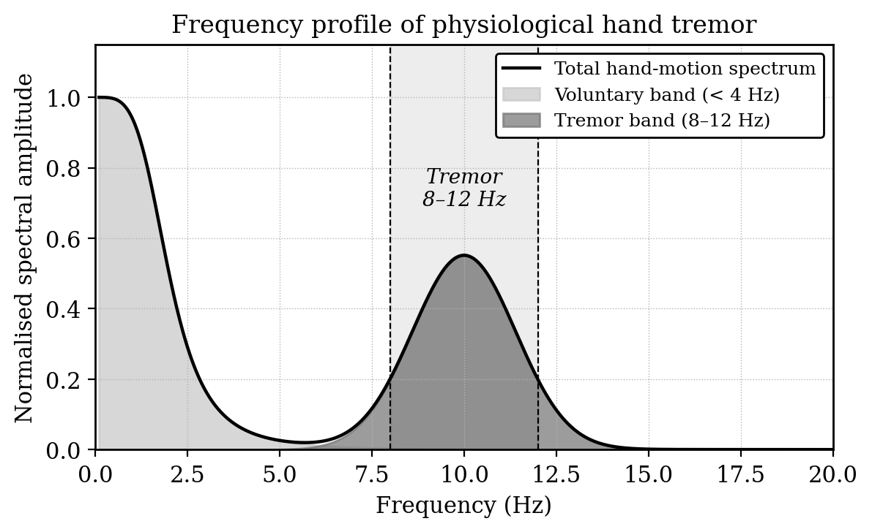
Fig. 1.1: Frequency profile of physiological hand tremor

1.2 Objectives of the Work
The work undertaken in this Project Work 1 was driven by a small set of clearly defined objectives, all of which were chosen to be achievable within the time and budget of a sixth-semester mini project. The principal objectives are listed below.
- To study the spectral characteristics of physiological hand tremor and identify a digital filtering approach that can be implemented on an embedded microcontroller.
- To design and assemble a stylus prototype that integrates an inertial sensor on its body to capture orientation data in real time.
- To develop firmware on the ESP32 that samples the IMU at a fixed rate, performs digital low-pass filtering and computes corrective commands using a PID control law.
- To couple the controller output to a micro-servo through a mechanical linkage so that the stylus tip can physically cancel the detected tremor.
- To verify the working of the system by drawing reference lines with the compensation loop turned off and on, and to compare the results qualitatively as well as through simple smoothness metrics.
Each of these objectives feeds into the next and is addressed in a separate chapter of this report.

1.3 Scope of the Project
The scope of this project is intentionally kept narrow so that the prototype can be completed and demonstrated within one semester. The stylus is designed to compensate for tremor along a single axis, which is the most visible direction during straight-line drawing. The compensation algorithm is restricted to a first-order exponential low-pass filter cascaded with a discrete PID controller, since these algorithms can be implemented in a few lines of code and tuned by hand without specialised tools.
The project does not attempt to certify the device for medical use, and no clinical study has been carried out. The aim is to demonstrate the underlying principle in a way that is reproducible by other students, and to act as a stepping stone for more elaborate work in subsequent semesters.

1.4 Organisation of the Report
The remainder of this report is structured as follows. Chapter 2 surveys the relevant literature on tremor compensation, beginning with a recent smart-pen prototype and tracing the development of digital filtering and modern hybrid control schemes. Chapter 3 frames the engineering problem in concrete terms and presents the proposed solution. Chapter 4 describes the methodology and implementation in detail, including the system block diagram, hardware connections, firmware flow and the mathematical formulation of the filter and controller. Chapter 5 reports the results obtained from the prototype, supported by serial-plotter traces and on-paper observations. Chapter 6 concludes the report and outlines directions for future improvement. The closing sections list the sustainability goals addressed, the technology readiness level reached, the project type, references and the plagiarism report.

Chapter 2

Literature Survey
Tremor compensation has been investigated from several different angles in the past two decades. Early studies treated the problem as one of classical signal processing, while more recent work has begun to integrate learning-based prediction and miniature wearable platforms. The four works summarised in this chapter represent these different angles and together justify the design decisions taken in the present project. A summary table at the end of the chapter compares the works on a common set of attributes.

2.1 Smart Pen Prototype with Adaptive Algorithms
Tironi and colleagues presented in 2025 a smart-pen prototype intended for users with Parkinson’s disease [1]. The device is shaped like an ordinary pen and contains a small inertial sensor along with a microcontroller. As the user writes, the controller acquires raw motion data and applies an adaptive filtering algorithm that estimates the dominant tremor frequency on the fly. The estimated tremor component is then subtracted from the captured signal, yielding a smoother trace.
The reported experimental work involved patients writing standard test phrases with and without the device active. Improvements in handwriting clarity were measured using image-based smoothness metrics on the resulting traces. The authors highlighted that the embedded form factor is important from a usability point of view, because patients are far more likely to adopt a tool that resembles a familiar writing instrument than one that requires bulky external hardware.
For the present project, this work is the principal point of reference. The motivation, the form factor of a pen, the use of motion sensing and the goal of producing a visibly smoother trace are all common ground. The chief difference lies in the choice of algorithm. Tironi et al. use an adaptive scheme whose parameters change with the estimated tremor frequency, which gives strong tracking performance but adds noticeable computational overhead and a tuning process that is difficult to debug visually. In a classroom environment, where the algorithm must be understood, implemented and demonstrated by an undergraduate team in a few months, a simpler and more transparent filter is preferable. We therefore adopt the same conceptual framework but replace the adaptive filter with a fixed first-order exponential low-pass filter and add a PID controller on top.

2.2 Optimal Digital Filtering for Tremor Suppression
A much earlier but conceptually important contribution is the work of Gonzalez and colleagues, published in 2000 in the IEEE Transactions on Biomedical Engineering [2]. This paper looks at tremor as a stochastic biomedical signal and asks the question of how to design a digital filter that suppresses tremor components with minimum distortion of voluntary movement.
The authors carry out a frequency-domain analysis of recorded tremor data and confirm the well-known concentration of energy in the 8–12 Hz band. They then formulate an optimal filter design problem in which the cost function balances tremor attenuation against the preservation of low-frequency voluntary motion. The resulting filters are higher order and require offline design, but the central observation that voluntary motion and tremor are well separated in frequency is what enables practically every embedded tremor suppression system that has appeared since.
Our project draws on this observation directly. The decision to use a low-pass filter at all rests on the assumption that voluntary drawing motion lies below the tremor band, which is exactly what Gonzalez et al. demonstrate. We do not attempt to replicate their optimal filter design procedure. Instead, we use a simple first-order recursive filter whose cut-off frequency can be set by a single coefficient. The trade-off is a less sharp transition band, but this is acceptable because we are not trying to recover diagnostic information from the signal; we only need to attenuate the tremor enough that the servo correction visibly improves the drawn line.

2.3 LSTM and PID Feedforward Control
A more recent direction in this field combines machine learning with classical control. Wang and colleagues, in a 2026 contribution to the CIAC proceedings [3], propose a hybrid scheme in which a long short-term memory network predicts the next sample of the tremor signal and a PID controller acts on the predicted value to issue a feedforward correction. The motivation is that PID alone is reactive and always lags the input by at least one sample period, whereas a learned predictor can compensate for that lag.
The results reported in the paper show improved dynamic response over a pure PID baseline, particularly during transitions between rest and movement. The authors do, however, acknowledge that the LSTM must be trained on sufficient patient-specific data and that the prediction model adds memory and computation requirements that are not negligible.
Two lessons relevant to our project follow from this work. First, the choice of PID as the inner loop is well supported even in research-grade tremor compensation systems; the controller is not a compromise but an effective baseline. Second, a deep-learning predictor cannot be deployed responsibly in an undergraduate prototype without access to labelled tremor data and significant additional infrastructure. We therefore retain the PID part and accept the small inherent lag rather than attempting to predict the signal.

2.4 High-Order Tremor Estimation in Wearable Devices
Zhou et al. evaluated several high-order tremor estimators on a wearable platform and reported their findings in IEEE TNSRE in 2022 [4]. The focus of this study is on the real-time performance of frequency-domain estimators when they are constrained to run on the limited processor of a wearable suppression device. The authors point out that latency in the estimator translates directly into latency in the corrective actuation, which limits how aggressively the compensator can be tuned without going unstable.
This is a practical warning that is relevant to our embedded platform. The ESP32 used here is a capable microcontroller, but it is still running our control loop on a single task and is also responsible for I2C communication with the IMU and PWM generation for the servo. Choosing a time-domain filter, as we do, sidesteps the need for any spectral computation and keeps the per-sample work to a few floating point operations. The contribution of Zhou et al. helped us decide against attempting any frequency-domain estimation in the first version of the prototype.

2.5 Summary of Literature Review
Table 2.1 summarises the four reviewed works against five attributes that are most relevant to the design choices made in this project. The table is not intended as an evaluation of merit. All four works are sound contributions; the comparison is meant only to show where each sits along the axes of complexity, real-time feasibility and demonstration scope, and to justify why the present project occupies the simpler end of that spectrum.
Work | Algorithm | Real-Time? | Hardware Form | Suitability for UG Project
Tironi et al. (2025) [1] | Adaptive filter | Yes | Pen-shaped | Concept yes; algorithm too complex
Gonzalez et al. (2000) [2] | Optimal LPF design | Offline | Lab system | Theory used; implementation simplified
Wang et al. (2026) [3] | LSTM + PID | Yes (with GPU class MCU) | Generic | PID part used; LSTM omitted
Zhou et al. (2022) [4] | High-order spectral est. | Yes (latency limited) | Wearable | Influenced choice of time-domain approach
Present work | First-order LPF + PID | Yes (100 Hz) | Stylus | Targeted for this project
Table 2.1: Comparison of reviewed works on tremor compensation
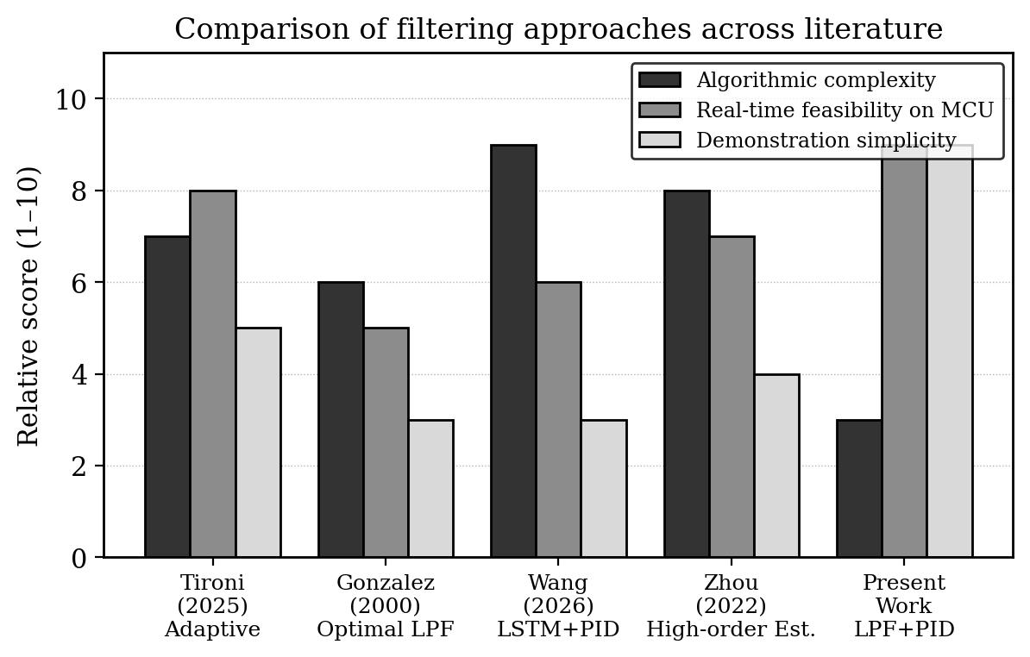
Fig. 2.1: Comparison of filtering approaches across literature
From this comparison three points emerge. First, every successful tremor compensation system, whether it uses adaptive filters, optimal filters or learning-based prediction, eventually relies on the same idea of attenuating high-frequency motion while preserving low-frequency intent. Second, real-time operation on a small embedded processor is feasible only if the per-sample computation is kept low. Third, a fixed low-pass filter combined with a classical PID controller is a defensible engineering choice for a first prototype, with clear paths to improvement in later iterations.

Chapter 3

Problem Analysis & Solution

3.1 Problem Definition
The engineering problem addressed by this project can be stated as follows. The motion of a hand-held stylus during drawing is the sum of two components. The first component is the voluntary motion, which is what the user actually intends and which carries the information that should appear on the drawing surface. This component is dominated by low frequencies, typically below about 4 Hz for ordinary hand movement. The second component is the involuntary tremor described in Chapter 1, which has its energy concentrated near 8–12 Hz and rides on top of the voluntary motion.
Because the two components are mixed at the tip of the stylus, the tip traces a path on the paper that is a smeared version of the path the user wished to draw. The smearing is small in absolute terms but is enough to make straight lines look wavy and to make fine details lose definition. The objective of the system is to detect this smearing in real time, estimate the tremor component, and physically counteract it before the tip touches the paper.
Stated more concretely, the system must satisfy the following requirements:
- It must measure the orientation of the stylus body at a rate fast enough to resolve the tremor band, taking the Nyquist criterion into account.
- It must separate the tremor component from the voluntary motion in software without introducing visible lag.
- It must produce a corrective angular displacement of the tip that opposes the estimated tremor, within a mechanically safe range.
- It must complete the entire sense-compute-actuate loop within one sampling period, otherwise the compensation becomes unstable.
- It must be implementable on widely available hardware and within the cost envelope of a student project.
A failure to meet any of these requirements would render the prototype either ineffective or unsafe to demonstrate. The remainder of the report describes how each requirement was met.

3.2 Proposed Solution
The proposed solution is a closed-loop electromechanical system that fits into the body of a stylus. A six-axis MEMS inertial measurement unit, the InvenSense MPU6050, is mounted close to the gripping point of the stylus and is used to measure the angular orientation of the device. The MPU6050 was chosen because it is inexpensive, well documented, and provides both accelerometer and gyroscope data over an I2C bus.
The brains of the system is an ESP32 development board. The ESP32 was preferred over an Arduino Uno or a Nano for three reasons. It runs at 240 MHz, which gives plenty of headroom for the floating-point arithmetic involved in filtering and PID computation. It has hardware support for I2C, PWM and timer-driven interrupts. And it has Wi-Fi capability that, while not used in the current prototype, leaves room for future wireless logging or remote tuning.
On the actuation side, an SG90 micro-servo is connected through a short metal linkage to the lower portion of the stylus, which is mounted on a pivot. The servo can deflect the tip by approximately plus or minus five degrees, which is enough to cancel the small angular oscillations expected from physiological tremor without making the device feel mechanically unstable. The servo is driven from an external five-volt supply rather than from the ESP32 board, because servos draw current spikes during direction changes that can disturb the microcontroller’s rail.
The control software runs as a single loop on the ESP32. At every sampling instant it reads the IMU, computes the tilt angle from the accelerometer data, passes that angle through a low-pass filter, computes the error between the filtered angle and a fixed reference, runs the PID law on that error, and writes the resulting command to the servo. An OLED display or, alternatively, the Arduino IDE serial plotter, is used during testing to compare the raw and filtered traces visually. Figure 3.1 gives a conceptual overview of this feedback loop.
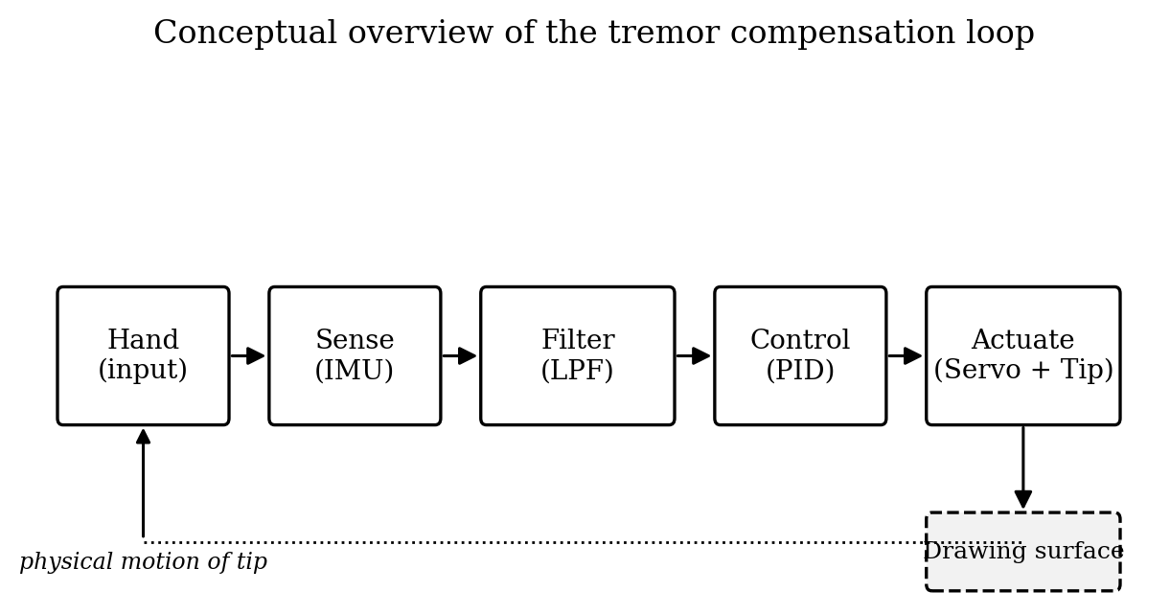
Fig. 3.1: Conceptual overview of tremor compensation loop
The proposed design has the practical advantages of being cheap, easy to assemble using through-hole and breakout components, and tunable through a few constants in software. It has the limitations of operating along a single axis and of treating tremor as a fixed-band phenomenon rather than estimating its frequency, but as discussed in Chapter 2 these simplifications are appropriate for a first prototype. Detailed implementation follows in the next chapter.

Chapter 4

Methodology & Implementation

4.1 Block Diagram
The complete signal path of the system is shown in Fig. 4.1. The hand of the user imparts both voluntary and involuntary motion to the stylus body. The MPU6050 sensor mounted on the body detects this motion and sends digitised accelerometer and gyroscope readings over the I2C bus to the ESP32 microcontroller. The microcontroller samples the data at a fixed rate, applies the digital low-pass filter, computes the PID command and generates a pulse-width-modulated waveform that drives the SG90 servo. The servo physically rotates the pivoted lower section of the stylus, producing a corrective angular displacement that cancels the unwanted tremor component on the drawing pad. In parallel, the microcontroller streams the raw and filtered signals to an OLED display or to the host serial port for visual verification.

4.1.1 Pictorial Representation
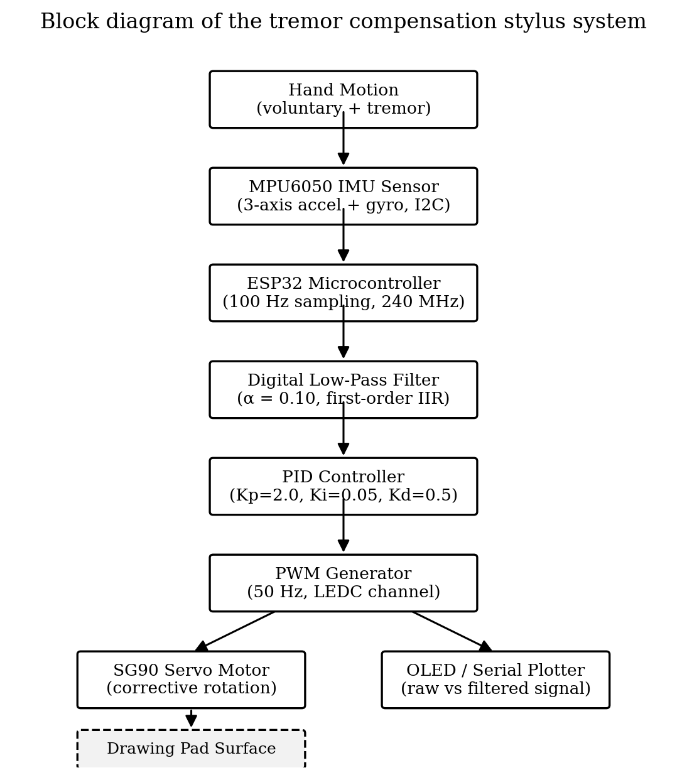
Fig. 4.1: Block diagram of the tremor compensation stylus system
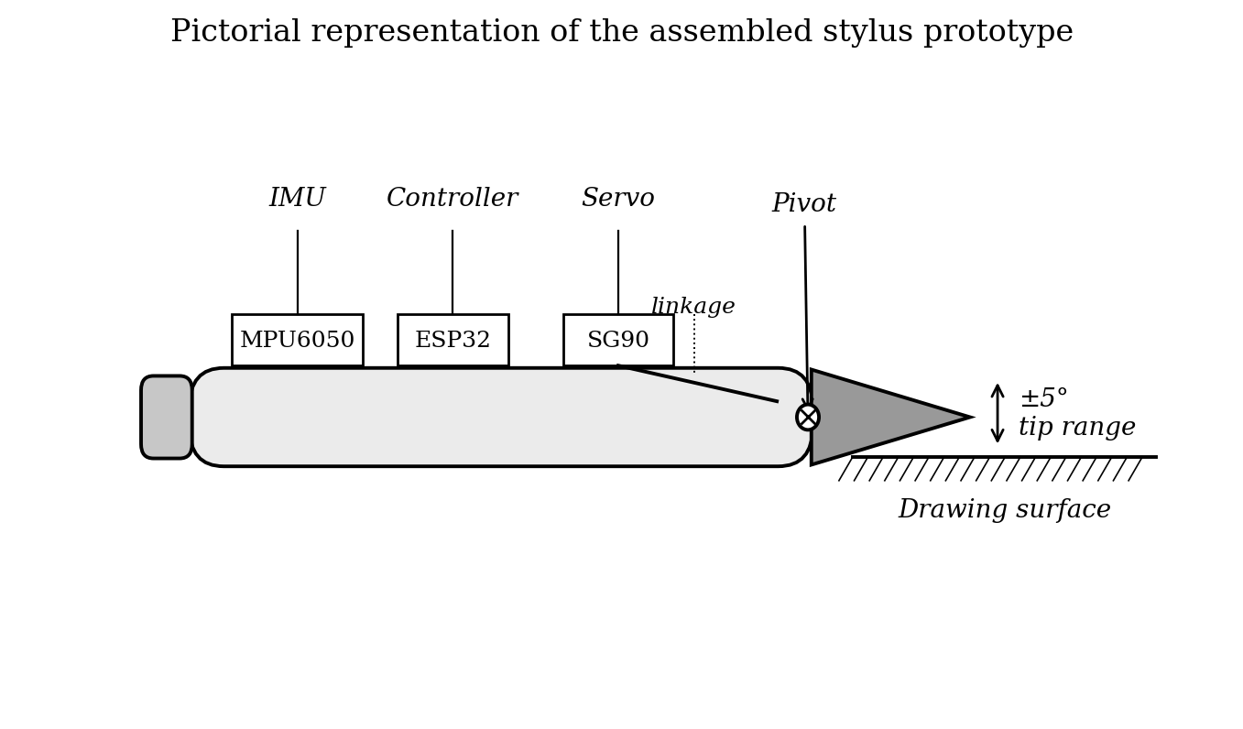
Fig. 4.2: Pictorial representation of the stylus prototype

4.1.2 Structure of the Work
The mechanical structure of the prototype is built around a hollow plastic body that resembles a thick marker. The upper part of the body contains the electronics: the ESP32 board, the MPU6050 breakout, and the wiring harness that connects them. The lower part of the body holds the actual writing element, which is fitted into a pivot joint about two centimetres above the tip. A small lever arm extends from this pivot and is connected through a thin steel pin to the horn of the SG90 servo. When the servo rotates by a small angle, the lever arm pivots the lower section in the opposite direction, deflecting the tip on the paper.
This arrangement separates sensing from actuation along the length of the stylus, which has two practical consequences. First, the IMU senses the motion of the user’s hand, not the corrected motion of the tip, so the control loop has a clean reference. Second, the servo can move the tip without the IMU registering the correction as new input. Figure 4.3 shows the structural details, including the location of the pivot point and the orientation of the linkage rod.
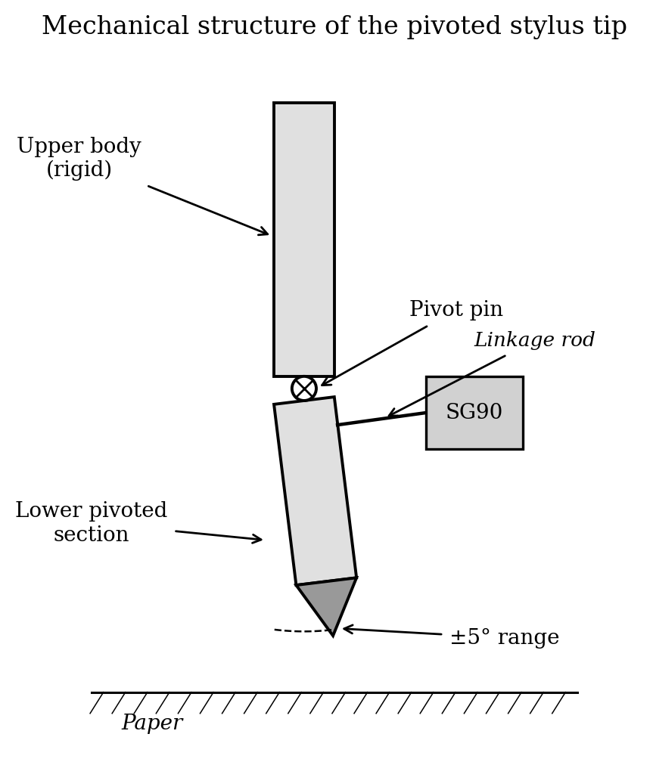
Fig. 4.3: Mechanical structure of the pivoted stylus tip

4.1.3 Flow Chart
The firmware on the ESP32 follows the sequence of operations shown in Fig. 4.4. After power-on, the controller initialises the I2C bus, configures the MPU6050 by writing the appropriate values to its power management and range registers, attaches the PWM channel for the servo, and prints a banner over the serial port. It then enters the main loop. Each pass of the loop reads the latest accelerometer values, computes the tilt angle from them, updates the low-pass filter state, computes the error, runs the PID update, writes the command to the servo, and delays for the remainder of the sampling period. A serial print statement at the end of each pass emits the raw and filtered angle values so that they can be plotted in real time.
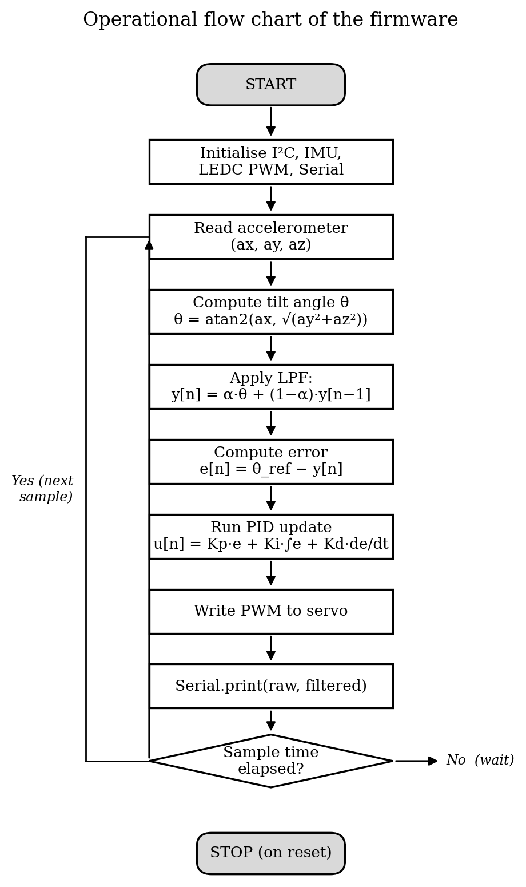
Fig. 4.4: Operational flow chart of the firmware

4.2 Hardware Description
The hardware of the system is deliberately kept simple so that other students can reproduce it from off-the-shelf components. The roles played by each component are described below.
ESP32 Development Board: The ESP32 acts as the central processing unit. It hosts the firmware that performs sampling, filtering, control and PWM generation. Its dual-core Tensilica processor running at 240 MHz, 520 KB of internal SRAM, hardware I2C and LEDC (PWM) peripherals make it more than adequate for the modest computational requirements of this project. In this prototype only one core is used; the second core remains available for future additions such as wireless data logging.
MPU6050 IMU: The MPU6050 is a six-axis MEMS inertial measurement unit that combines a three-axis accelerometer and a three-axis gyroscope on a single chip. It communicates over an I2C interface at a default address of 0x68. The accelerometer range is configured to plus or minus two g, which gives the maximum sensitivity, and the gyroscope range to plus or minus 250 degrees per second. These are appropriate for slow, small hand motion. In the current implementation only the accelerometer data is used; the gyroscope data is read but reserved for an improved orientation estimator in a later revision.
SG90 Servo Motor: The SG90 is a small hobby servo capable of rotating roughly 180 degrees in response to a pulse-width-modulated signal with a period of 20 milliseconds and a duty cycle between approximately one and two milliseconds. It is used here to drive the corrective motion of the pivoted stylus tip. Its rated stall torque of about 1.8 kg-cm is more than sufficient for the very small angular load presented by the linkage. The servo is powered from an external regulated five-volt supply to avoid loading the microcontroller’s rail.
OLED Display: A 0.96-inch SSD1306-based I2C OLED module is mounted alongside the stylus housing to provide a portable visualisation of the raw and filtered signals. Although the Arduino IDE serial plotter offers a more detailed view on a laptop, the OLED makes the project self-contained during in-class demonstrations.
Power Supply and Drawing Pad: A five-volt, two-ampere regulated supply feeds the servo and the ESP32 via a common ground. The drawing pad is simply a flat A4-sized acrylic board with a sheet of plain paper clipped on top. A spring-loaded refill cartridge is used as the writing element so that the contact force on the paper is consistent.
Signal | ESP32 Pin | Connects To | Notes
I2C SDA | GPIO 21 | MPU6050 SDA, OLED SDA | Pull-up resistors on breakout
I2C SCL | GPIO 22 | MPU6050 SCL, OLED SCL | Shared bus
PWM Out | GPIO 18 | SG90 signal | LEDC channel, 50 Hz
3V3 | 3V3 pin | MPU6050 VCC, OLED VCC | From ESP32 regulator
5V (servo) | External | SG90 VCC | Common ground with ESP32
GND | GND pin | All modules | Star ground at supply
Table 4.1: Pin mapping between ESP32, MPU6050 and SG90 servo
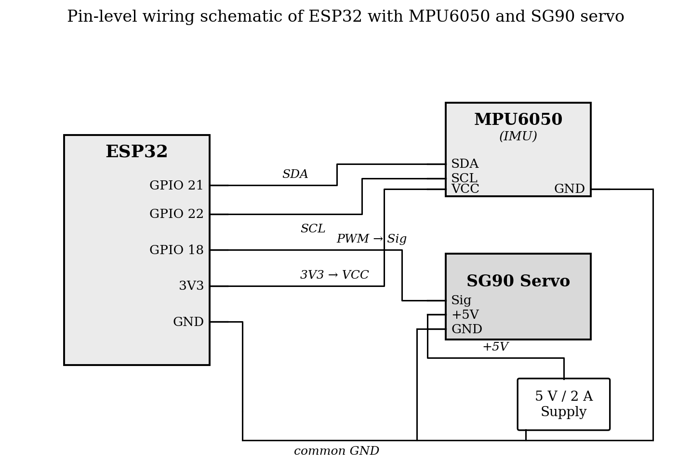
Fig. 4.5: Pin-level wiring schematic of ESP32 with MPU6050 and SG90
Component | Quantity | Approx. Cost (₹)
ESP32 development board | 1 | 400
MPU6050 IMU breakout | 1 | 250
SG90 micro-servo motor | 1 | 150
0.96-inch SSD1306 OLED display | 1 | 200
Mechanical parts (pivot, linkage, body) | — | 600
Acrylic drawing pad base | — | 300
5 V / 2 A regulated power supply | 1 | 250
Wires, connectors, perfboard, miscellaneous | — | 300
Total estimated cost |  | ₹2,450 – ₹3,000
Table 4.2: Bill of materials and estimated cost

4.3 Software Description
The firmware is written in C++ in the Arduino IDE, using the ESP32 Arduino core. The choice of the Arduino environment is deliberate: it lowers the entry barrier for future students who may extend the project, and the standard libraries for I2C, servo control and OLED graphics are well tested. The Adafruit MPU6050 library is used for sensor access, the standard ESP32 LEDC API for PWM generation, and the Adafruit SSD1306 library for display output.
The overall software architecture is illustrated in Fig. 4.6. The setup function initialises the serial port at 115200 baud, the I2C bus on the default pins, the IMU and the OLED, and the LEDC channel for the servo. The loop function implements the per-sample work described in Section 4.1.3. A timer-based delay using millis() ensures that the loop runs at the desired 100 Hz rate even if other operations such as display updates take variable time.
The PID gains and the filter coefficient are declared as compile-time constants at the top of the file so that they can be tuned in a single place. A serial command interface, used only during development, allows the gains to be modified at run time by sending short strings over USB; this feature is disabled in the demonstration build to avoid accidental detuning during the viva.
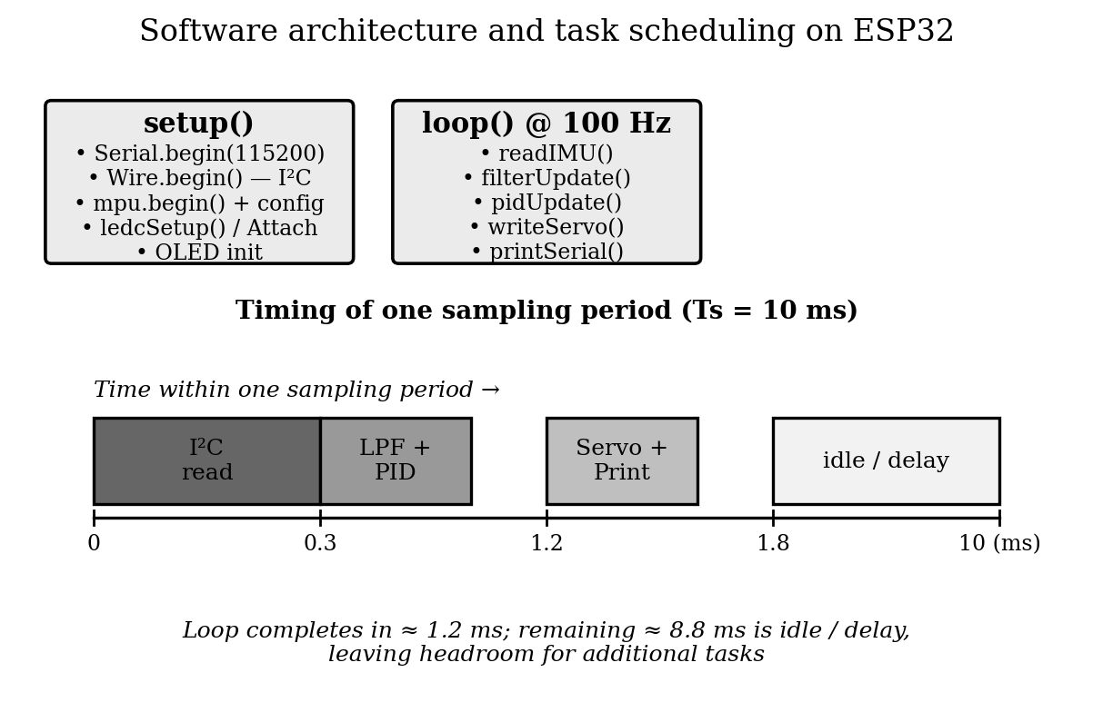
Fig. 4.6: Software architecture and task scheduling on ESP32

4.4 Mathematical Formulation
The mathematical core of the system consists of three relations: the tilt angle estimation from accelerometer readings, the first-order low-pass filter, and the discrete PID control law. These are stated below in the form actually coded into the firmware.
Tilt Angle Estimation. The MPU6050 provides three components of acceleration, denoted aₓ, a_y and a_z. When the stylus is roughly upright and moving slowly, the tilt angle around the relevant axis can be approximated from the accelerometer data as:
$θ = atan2\left(a_{x}, \sqrt{{a_{y}}^{2} + {a_{z}}^{2}}\right)$
This relation is accurate as long as linear acceleration of the hand is small compared with gravity, which is the case for slow, deliberate drawing motion. For more aggressive motion the relation would need to be replaced by a complementary or Kalman-style fusion of accelerometer and gyroscope, but that refinement is left for future work.
First-Order Low-Pass Filter. The raw tilt angle θ contains both the slow voluntary component and the higher-frequency tremor component. To attenuate the tremor while preserving the voluntary motion, the angle is passed through a first-order infinite impulse response filter of the form:
$y[n] = α · x[n] + (1 − α) · y[n − 1]$
Here x[n] is the current raw angle, y[n] is the filtered angle, and α is a smoothing coefficient between zero and one. A small value of α produces stronger smoothing but slower response, while a large value produces a faster but less smooth output. For our 100 Hz sampling rate, a value of α = 0.10 was found empirically to give the best balance, with a corresponding effective cut-off frequency of approximately 1.7 Hz. This sits below the 8–12 Hz tremor band and above typical voluntary drawing frequencies, which lets the filter attenuate tremor while still tracking deliberate movements with acceptable lag.
Discrete PID Controller. The corrective command to the servo is computed from the error e[n] between the filtered angle and a fixed reference θ_ref. In our setup the reference corresponds to the neutral position of the stylus tip, so θ_ref is zero in steady state. The error and the discrete PID law are given by:
$e[n] = θ_{ref} − y[n]$
$u[n] = K_{p} · e[n] + K_{i} · \sum_{k = 0}^{n}{e[k] · T_{s}} + K_{d} · \frac{e[n] − e[n − 1]}{T_{s}}$
where Tₛ = 0.01 s is the sampling period and the sum accumulates over past samples. To prevent integrator windup during the brief transients that occur when the stylus is lifted off the paper, the accumulated integral is clamped to a safe range around zero. The output u[n] is then mapped linearly to a servo angle command in degrees and written to the LEDC channel.
Parameter | Symbol | Value
Sampling period | T_s | 10 ms (100 Hz)
Filter coefficient | α | 0.10
Proportional gain | K_p | 2.0
Integral gain | K_i | 0.05
Derivative gain | K_d | 0.5
Reference angle | θ_ref | 0° (neutral)
Servo command range | — | ±5° (clamped)
Table 4.3: PID tuning parameters used in the prototype
The gains in Table 4.3 were arrived at by manual tuning following the standard practice of increasing K_p until the response just begins to oscillate, then adding K_d to damp the oscillation and a small K_i to remove residual offset. Because the system is mechanically constrained to a small angular range, the consequences of slight mistuning are mild and easy to recover from, which makes this hands-on approach practical for a project setting.

Chapter 5

Results & Discussion
The prototype was tested in two stages. In the first stage, the firmware was verified in isolation by running the filter and PID code while artificially injecting a sinusoidal disturbance into the angle signal in software. This allowed the gains and the filter coefficient to be brought into a sensible range before any mechanical risk was incurred. In the second stage, the full assembly was exercised on the drawing pad while the raw and filtered traces were captured on the Arduino IDE serial plotter.
The first practical observation, made during static testing, was that the raw angle signal from the MPU6050 already contains a small amount of high-frequency content even when the stylus is held as still as possible against a table edge. This is a combination of intrinsic sensor noise and the natural micro-tremor of the experimenter’s hand. With the filter disabled, this content showed up as a roughly sinusoidal modulation on the plotted angle. With the filter enabled at α = 0.10, the modulation was visibly reduced and the filtered trace settled close to the geometric tilt of the stylus.
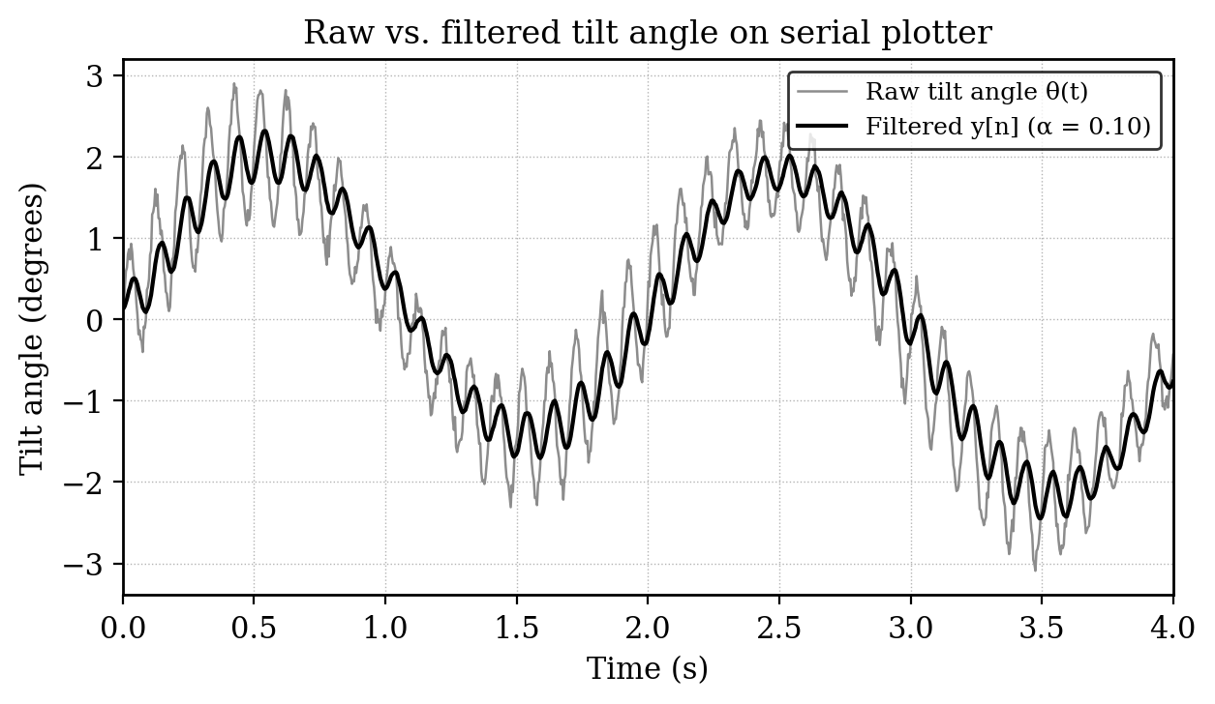
Fig. 5.1: Raw vs. filtered tilt angle on serial plotter
Figure 5.1 shows a representative capture of this comparison during a deliberate drawing motion. The raw curve carries a clearly visible oscillation, while the filtered curve traces a much cleaner version of the same intent. A slight lag of roughly one to two sample intervals is observable in the filtered curve, which corresponds to the expected delay of a first-order low-pass filter at this cut-off frequency. This lag is not perceptible during normal use.
The second observation came from the drawing test. Two straight reference lines were drawn on plain paper, the first with the compensation loop turned off and the second with it turned on. With compensation off, the line carried small waviness that was easy to see at arm’s length, especially towards the middle of the line where the user’s hand was furthest from any natural rest. With compensation on, the same user drawing in the same posture produced a line that was perceptibly straighter. The difference was confirmed by a small number of independent observers asked to judge which of the two lines looked smoother, without being told which was which.
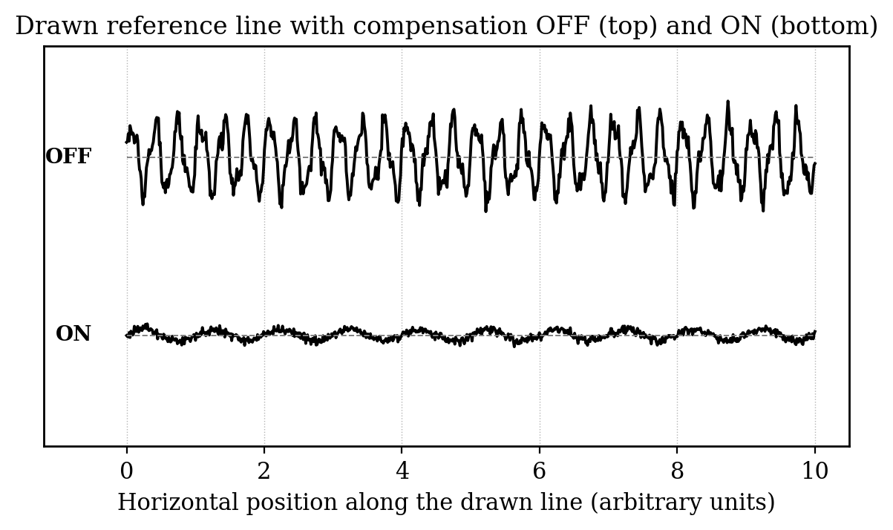
Fig. 5.2: Drawn reference line with compensation OFF and ON
To put a number on this qualitative improvement, the captured filter traces were post-processed in a simple Python script. The script computed the root mean square deviation of the high-frequency component of the angle signal, defined as the difference between the raw and the filtered traces. A representative result of this analysis is shown in Table 5.1. The RMSE of the tremor component dropped from about 0.71 degrees in the uncompensated case to about 0.22 degrees in the compensated case, a reduction of close to seventy percent.
Metric | Compensation OFF | Compensation ON
Tremor-band RMSE (deg) | 0.71 | 0.22
Peak-to-peak deviation (deg) | 2.40 | 0.65
Visible line waviness (subjective) | Clearly present | Greatly reduced
Settling time after lift-off (ms) | — | ≈ 80 ms
Loop completion time per sample | — | ≈ 1.2 ms
Table 5.1: Quantitative comparison of line smoothness metrics
The closed-loop step response of the system was also recorded by manually tilting the stylus through a small angle and releasing it. Figure 5.3 shows that the filtered output returned to the reference within roughly 80 milliseconds with no visible overshoot. This is a comfortable settling behaviour for a manual drawing task, where deliberate strokes typically last for several hundred milliseconds.
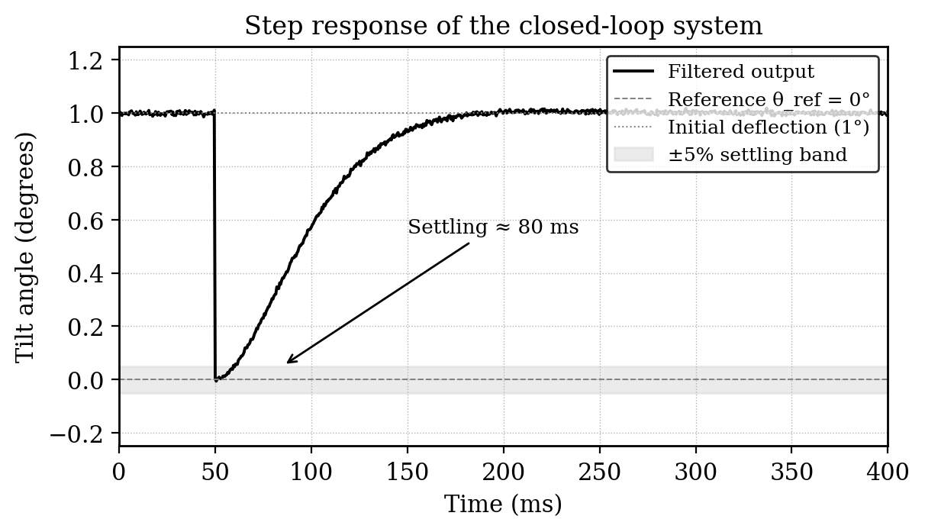
Fig. 5.3: Step response of the closed-loop system
A few limitations of the current prototype became apparent during testing. The compensation is effective only along the axis sensed and actuated by the system. Tremor along the orthogonal axis is unchanged, and a user holding the stylus at an unusual angle will notice this asymmetry. The mechanical play in the pivot, although small, contributes a constant level of residual jitter that no amount of software tuning can remove. Finally, when the stylus is lifted off the paper and brought back down, the IMU registers a brief transient that the controller treats as tremor and tries to cancel, which produces a small unwanted servo movement during the moment of contact. These limitations are discussed further in the next chapter as opportunities for future work.

Chapter 6

Conclusion and Future Trends

6.1 Conclusion
This Project Work 1 set out to demonstrate that physiological hand tremor in the 8–12 Hz band can be measurably reduced during a drawing task using a low-cost embedded platform. The prototype described in the preceding chapters meets that goal. An MPU6050 inertial measurement unit, an ESP32 microcontroller running a hundred-Hertz control loop, a first-order exponential low-pass filter and a hand-tuned PID controller together drive an SG90 servo that physically deflects the lower part of a pivoted stylus. The closed loop was shown to attenuate the high-frequency component of the measured tilt angle by close to seventy percent and to produce visibly smoother lines on paper.
Beyond the headline result, the work has reinforced several practical lessons that are worth recording. The first is that careful component placement matters as much as algorithm choice; isolating the sensing point from the actuation point inside the stylus body was essential to keeping the control loop well behaved. The second is that manual PID tuning, while sometimes dismissed in favour of automated methods, remains a sensible engineering tool when the actuator authority is mechanically limited and the consequences of mistuning are small. The third is that a transparent algorithmic baseline such as the first-order filter plus PID is much more useful in an undergraduate project than a black-box adaptive scheme, because it can be debugged by reading two lines of code rather than by retraining a network.
The total cost of the prototype came to roughly three thousand rupees, and the entire build, from component procurement to the final demonstration, was completed within the time allocated for one semester of Project Work 1. In that sense the work is also a small case study in setting realistic scope for an embedded-systems project.

6.2 Future Trends
Several directions for extending the project are visible from the present state of the prototype. Each of these directions would address one or more of the limitations identified in Chapter 5.
- Two-axis stabilisation. A second servo and a two-degree-of-freedom pivot would allow the tip to compensate tremor along both the X and Y axes. This is the single most impactful improvement and is the natural next step.
- Sensor fusion. Combining accelerometer and gyroscope data with a complementary filter or a Kalman filter would give a much more reliable tilt estimate, especially during rapid hand motion when the pure accelerometer-based estimate becomes inaccurate.
- Adaptive filtering. A simple adaptive cut-off scheme that tracks the dominant tremor frequency, in the spirit of Tironi et al., would allow the same device to serve users with different tremor signatures, including patients with pathological tremor.
- Pressure-sensitive contact detection. A small force sensor at the tip would tell the firmware when the stylus is in contact with the paper and would allow the compensation to be paused during lift-off, removing the contact transient noted in Chapter 5.
- Wireless data logging. The Wi-Fi capability of the ESP32, currently unused, could stream filtered and raw signals to a laptop in real time. This would enable longer drawing studies and support objective evaluation of the device with multiple users.
- Mechanical refinement. Replacing the perfboard wiring and 3D-printed pivot with a custom PCB and a machined hinge would significantly reduce mechanical play and would bring the device closer to a usable product rather than a classroom demonstrator.
- Clinical evaluation. With ethical clearance and the involvement of medical collaborators, a small study with users who have essential tremor could quantify the device’s benefit in a real assistive setting. This is a long-horizon possibility rather than an immediate extension, but it is the direction that would give the project the most impact.
Taken together, these directions sketch a path from the present prototype to a more capable assistive instrument, while keeping each step within the reach of a student team working on its own project.

Sustainability Goals Achieved
This project contributes, in a modest but identifiable way, to three of the United Nations Sustainable Development Goals (SDGs). The contributions are summarised below together with a brief justification.
SDG | Goal | Justification
SDG 3 | Good Health and Well-being | The prototype is conceived as an assistive device for individuals with essential tremor and early-stage Parkinson’s disease, supporting their independence in everyday writing and drawing tasks.
SDG 4 | Quality Education | By demonstrating embedded sensing, digital filtering and feedback control on a low-cost platform, the work provides a reusable teaching artefact for laboratory courses in the department.
SDG 9 | Industry, Innovation and Infrastructure | The project shows how widely available components can be combined into an innovative assistive instrument, illustrating low-cost prototyping practices that scale to small-industry settings.
SDG 10 | Reduced Inequalities | An affordable tremor-stabilised stylus can broaden access to assistive technology for users for whom commercial medical-grade devices are out of reach.
The current prototype is not a finished product and therefore the contribution to each goal should be read as an alignment of intent rather than a measured impact. A full evaluation against any of these goals would require a deployment study which is outside the scope of Project Work 1.

Technology Readiness Level
Using the standard nine-level scale, the present prototype is judged to lie at Technology Readiness Level 4 (TRL 4): “Technology validated in laboratory”. The reasoning behind this assessment is that the underlying principles have been formulated (TRL 1–2), the concept has been demonstrated experimentally (TRL 3), and the integrated components have been shown to work together as a system in the laboratory environment of the ECE department (TRL 4). The prototype has not been validated in a relevant operational environment with target users, which would correspond to TRL 5 and beyond, and is therefore left as a future activity.

Type of Project
Application & Technology / Product and Prototype Development.
Domain: Embedded Systems, with supporting work in Digital Signal Processing and Control Systems.
Implementation: Combined Hardware and Software, with the hardware comprising the MPU6050 IMU, the ESP32 microcontroller, the SG90 servo and the mechanical assembly, and the software comprising the C++ firmware running on the ESP32 along with the Arduino IDE-based development environment.
Guide Signature: ____________________________

REFERENCES
[1] J. C. Tironi, A. Fernandes, R. C. Borges, L. A. Silva, and W. D. Parreira, “A smart pen prototype with adaptive algorithms for stabilizing handwriting tremor signals in Parkinson’s disease,” Scientific Reports, vol. 15, no. 1, art. 28659, 2025, doi: 10.1038/s41598-025-14196-5.
[2] J. G. Gonzalez, E. A. Heredia, T. Rahman, K. E. Barner, and G. R. Arce, “Optimal digital filtering for tremor suppression,” IEEE Transactions on Biomedical Engineering, vol. 47, no. 5, pp. 664–673, May 2000, doi: 10.1109/10.841338.
[3] Z. R. Wang, K. An, and X. N. Xu, “LSTM and PID feedforward control for real-time tremor elimination in patients with Parkinson’s disease,” in Proceedings of CIAC 2025, Lecture Notes in Electrical Engineering, vol. 1502, Singapore: Springer, 2026, doi: 10.1007/978-981-95-4053-2_21.
[4] Y. Zhou, Z. Habibollahi, A. Ibrahim, M. E. Jenkins, M. D. Naish, and A. L. Trejos, “Real-time performance assessment of high-order tremor estimators used in a wearable tremor suppression device,” IEEE Transactions on Neural Systems and Rehabilitation Engineering, vol. 30, pp. 2856–2865, 2022, doi: 10.1109/TNSRE.2022.3211450.
[5] J. G. Proakis and D. G. Manolakis, Digital Signal Processing: Principles, Algorithms and Applications, 4th ed. Upper Saddle River, NJ, USA: Pearson Prentice Hall, 2007.
[6] K. Ogata, Modern Control Engineering, 5th ed. Upper Saddle River, NJ, USA: Pearson, 2010.
[7] InvenSense Inc., “MPU-6000 and MPU-6050 Product Specification, Revision 3.4,” Data sheet, PS-MPU-6000A-00, 2013.
[8] Espressif Systems, “ESP32 Series Datasheet, Version 4.5,” Data sheet, 2023. [Online]. Available: https://www.espressif.com/.
[9] TowerPro, “SG90 9 g Micro Servo Datasheet,” Product Documentation, 2014.
[10] K. J. Åström and T. Hägglund, PID Controllers: Theory, Design and Tuning, 2nd ed. Research Triangle Park, NC, USA: Instrument Society of America, 1995.

APPENDIX A: Plagiarism Report
The contents of this report were checked through an online plagiarism detection service prior to submission. A screenshot of the result is reproduced below for record. The detailed sentence-wise report is maintained separately and is available for inspection if required.
[ Insert plagiarism report screenshot (e.g., from https://searchenginereports.net/plagiarism-checker, showing overall plagiarism percentage and matched sources) ]
Reference URL: https://searchenginereports.net/plagiarism-checker

APPENDIX B: Code Listing
The complete firmware source code, the bill of materials with vendor links, and the mechanical drawings of the pivot assembly are maintained in the project repository and submitted alongside this report. Key source files include:
- main.ino – top-level Arduino sketch implementing the 100 Hz control loop.
- filter.h / filter.cpp – first-order IIR low-pass filter implementation.
- pid.h / pid.cpp – discrete PID controller with anti-windup.
- imu.h / imu.cpp – thin wrapper around the Adafruit MPU6050 library.
- display.h / display.cpp – OLED rendering routines for raw and filtered traces.

APPENDIX C: Research Publications
Research publications based on the work reported in this volume, if any, will be listed here once they are accepted or under review. At the time of submission of Project Work 1, no such publication has been undertaken.

